

I Year II Sem CAEGW Mock Test

Answer any Six questions

1. Draw a pentagon of 40 mm side with a side vertical. Attach a hexagon of same side with common vertical edge.
2. Draw the 2D drawings by using auto cad commands.

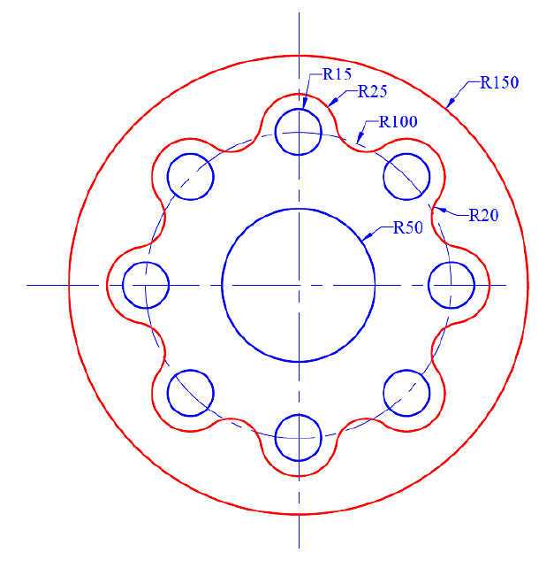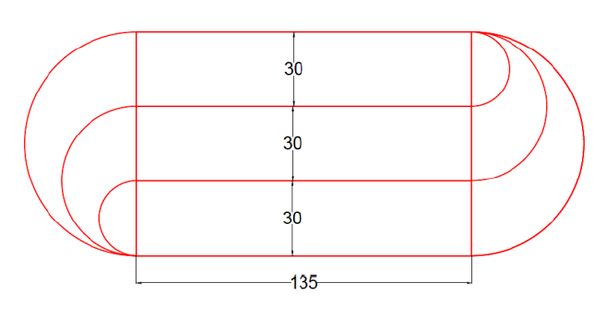

1. (b)
2. Draw the projections of the following points on the same XY line, keeping 30 mm distance between each projector. Name the Quadrants in which they lie.
   1. Point M is 30 mm below HP and 25 mm behind VP.
   2. Point R is 35 mm below HP and 35 mm in front of VP.
   3. Point U is on HP and 30 mm in front of VP.
   4. Point E is on VP and 35 mm below HP.
   5. Point H is on HP and 40 mm behind VP.
3. State the position and quadrants of the following points are situated:
   1. A point P; its front view is 50 mm above xy; the top view, 20 mm below the front view.
   2. A point Q, its projections coincide with each other 40 mm above xy.
   3. A point R, its top view is 45 mm below xy; and, front view is 20 mm above the top view.
4. A straight-line PQ has its end P 20 mm above the H.P. and 30 mm in front of the V.P. and the end Q is 80 mm above the H.P. and 70 mm in front of the V.P. If the end projectors are 60 mm apart, draw the projections of the line. Determine its true length and true inclinations with the reference planes.
5. The midpoint M of a line AB is 60 mm above H. P. and 50 mm in front of V. P. The line measures 80 mm long and inclined at an angle of 30° to H. P. and 45° to V. P. Draw its projections.
6. A pentagonal plane of side 30 mm is resting on a corner in the H.P. The side opposite to the corner in the H.P. is parallel to and 35 mm above H.P. and inclined at 45° to the V.P. Draw its three principal views.
7. A rectangular plane of edges 35 mm and 70 mm is resting on an edge in the H.P. The surface is inclined to the H.P. such that the top view appears as a square. Draw its projections when the edge resting on the H.P. is inclined at 30° to the V.P.

Upload your PDF file to below link

<https://bit.ly/CSEMT-I>